Kotlin Objects

Ryan Scott

Grand Canyon University  
CST-416 Mobile Game Design

Prof. Shad Sluiter

## Solo Learn Certificate Completion Screenshot:

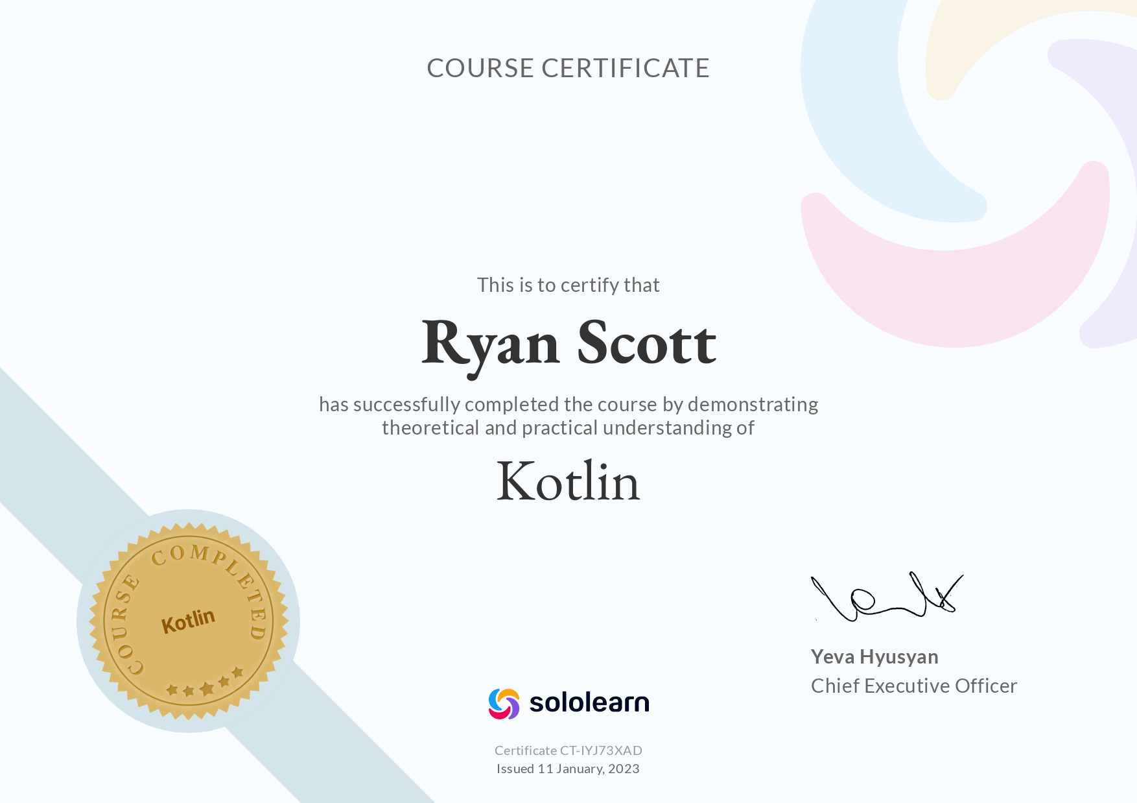

**Snowman Management Simulator Screenshots:**

0. Main Menu

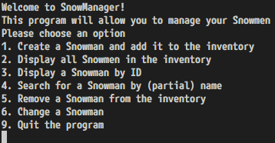

1. Add a new snowman to the inventory

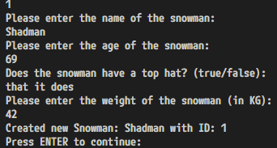

1. Display all snowmen in the inventory

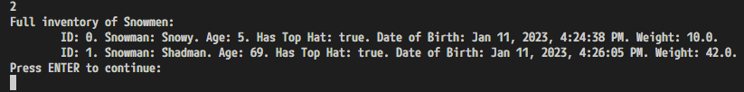

1. Show a single snowman given its id number

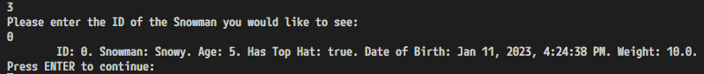

1. Search for a snowman by (partial) name

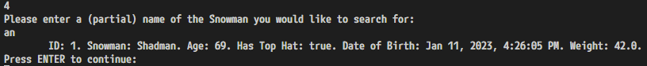

1. Delete a snowman

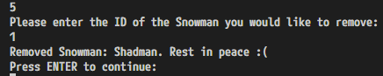

1. Change a snowman

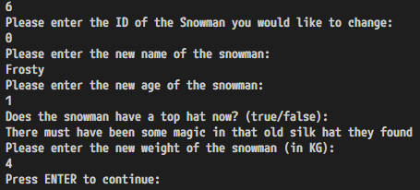



9. Quit the program

